
UNIVERSITY OF BATANGAS – LIPA CITY
COLLEGE OF ENGINEERING AND ARCHITECTURE
COMPUTER ENGINEERING

ERINX SMART HUB
ESP32-S3 Touchscreen Weather, Climate, Clock and Media Dashboard

PROJECT DOCUMENTATION
Embedded Systems Mini Project

Prepared by:
Carl Jayson Eli B. Bonaobra
CPE4A

October 13, 2026

1. Project Description

1.1 Introduction
ERINX Smart Hub is an embedded touchscreen dashboard developed for an ESP32-S3 CAM N16R8 microcontroller connected to a 3.5-inch SPI TFT display with touch input. It combines an internet-based weather display, a Philippine Standard Time clock, a DHT11 indoor temperature-and-humidity screen, and microSD-based photo and silent video viewing in a single menu-driven interface. The source archive identifies V5.1.3 as the latest delivered program.
The final interface is drawn in portrait at 320 × 480 pixels on a nominal 480 × 320 ILI9488-class module. The user opens Weather, Clock, DHT11, Gallery, Video or Settings from six home tiles. The ESP32-S3 reads touch coordinates, updates local sensor values, manages on-device preferences, retrieves online data through Wi-Fi and renders graphic assets stored on a microSD card.

1.2 Project Purpose
The project demonstrates practical embedded-system integration by coordinating peripheral input/output, periodic sensor sampling, network requests, non-volatile settings, local storage, JPEG decoding and a simple touchscreen user interface within one resource-constrained microcontroller.

1.3 Scope and Limitations
- The ESP32-S3 CAM is used as the main microcontroller and SD-card host; the attached camera is not used for capture or a photobooth in the archived V5.1.3 firmware.
- The outdoor weather page uses Open-Meteo data over the internet; it is different from the indoor DHT11 reading and does not measure hyperlocal outdoor conditions at the device.
- The network time display depends on Wi-Fi and successful NTP synchronization; without synchronization, uptime remains available.
- The image gallery reads baseline JPEGs on microSD. The video player accepts converted silent custom .evm files and does not directly decode MP4 or audio.
- Wi-Fi must be a supported 2.4 GHz personal network. The on-screen input shows the password by default and provides a SHOW/HIDE toggle.
- The final source stores Wi-Fi details in local NVS preferences and uses TLS certificate verification bypass (setInsecure) for weather requests; these are prototype-level security limitations.
- No new physical test, Arduino board-toolchain compilation, network throughput measurement or FPS measurement was performed while organizing this archive.

1.4 Embedded Systems Relevance
The ESP32-S3 interfaces with SPI-driven display/touch components, a digital DHT11 sensor, SDMMC storage and Wi-Fi. Its firmware runs timed sensor and weather updates, handles user interaction, maintains page state, decodes visual media and saves selected settings in non-volatile memory. This combination illustrates hardware-software interfacing, memory constraints, peripheral initialization, state machines and event-based control.

1.5 Development Versions
Development stage | Major change
Initial ESP32D prototypes | Display loading, touch calibration, no-touch and touch weather prototypes.
Smart Hub V3 | Improved blue weather dashboard and touch navigation.
V4.3–V4.5 | ESP32-S3 transition; integrated DHT11, clock and optimized screen redraws.
V4.6–V4.8 | RGB565 SD icons, interface theme and visual animations.
V4.9 | JPEG gallery and automatic photo slideshow.
V5.0 | Silent custom EVM-format video browser and player.
V5.1–V5.1.2 | City picker, on-screen Wi-Fi, PageTypes.h build fix and SDMMC diagnostic checks.
V5.1.3 (final) | Visible/masked Wi-Fi password input and graphical city dropdown chevron.

2. Objectives

2.1 General Objective
To design and implement an ESP32-S3-based touchscreen smart hub that displays network weather, Philippine time, local environmental readings and photo/video media through one integrated TFT interface.

2.2 Specific Objectives
- Initialize and control a 3.5-inch SPI touchscreen display with saved touch calibration.
- Create six navigable home functions and responsive page-specific touch controls.
- Fetch and display internet weather for Malvar, Tanauan, Lipa and Sto. Tomas.
- Read indoor temperature and relative humidity from a GPIO-connected DHT11 sensor.
- Display local clock information from network time synchronization and show uptime when necessary.
- Load raw RGB565 menu icons, JPEG photos and converted silent EVM videos from built-in SDMMC microSD storage.
- Provide an on-device Wi-Fi network scan and password keyboard with local settings persistence.
- Preserve software development versions, release notes, diagnostics and documentation in an organized repository.

3. Equipment and Materials

3.1 Hardware Components
Component | Specification / Qty | Purpose
ESP32-S3 CAM board | 1, N16R8 variant | Main controller; built-in SDMMC microSD host. Camera not utilized.
TFT touchscreen module | 1, 3.5-inch 480×320 SPI, assumed ILI9488/XPT2046 style | Portrait graphic output and touch user input.
DHT11 sensor | 1, module/sensor | Indoor air temperature and humidity readings on GPIO14.
microSD card | 1, FAT32-compatible | Stores menu icons, photos and EVM videos.
Jumper wires / breadboard | As needed | Electrical connection between S3, display and DHT11.
USB power / programming cable | 1 | Supplies board and transfers Arduino firmware.
Laptop / PC | 1 | Arduino IDE programming, media conversions and Serial testing.

3.2 Software, Libraries and Services
Software / library | Use
Arduino IDE + Espressif ESP32 core | Compile and upload C++ firmware for ESP32S3 Dev Module.
TFT_eSPI | TFT rendering, SPI display configuration and touch coordinates.
TJpg_Decoder | Decodes JPEG images and EVM JPEG frames for TFT drawing.
ArduinoJson v7 | Parses JSON current conditions returned by the weather API.
DHT sensor library + Adafruit Unified Sensor | DHT11 sensor interaction.
WiFi, HTTPClient, WiFiClientSecure, Preferences, SD_MMC / FS | Connectivity, requests, NVS persistence and card file access.
Open-Meteo forecast API | Weather conditions for user-selected coordinates.
NTP time service | Philippine timezone clock when internet is available.
Python Pillow + FFmpeg | PC-side conversion to silent custom EVM video files.

4. System Features and Requirements

4.1 Main Functional Features
Feature | Implementation in V5.1.3
Home / navigation | Six menu tiles with common BACK control and touch footer.
Weather | Current outdoor temperature, humidity, feels-like and wind data plus animated condition graphics; four city choices.
Clock | Network-synchronized Asia/Manila time and uptime indicator.
Indoor climate | DHT11 room temperature and humidity every ~3 seconds.
Photo gallery | Up to 40 photo entries, fullscreen JPEG view, next/previous and 7-second auto-slide.
Silent video | Up to 24 .evm files, file selection, play/pause, next/previous and loop setting.
Wi-Fi setup | Scan up to 12 nearby SSIDs, select and join, onscreen keyboard, password visibility toggle, save/forget.
Settings | Touch calibration, SD-card status and Wi-Fi setup access.

4.2 Non-Functional Requirements
- Responsiveness: periodic UI elements use partial redraws/cached text where implemented; controls respond to user touch events.
- Local operation: DHT11 and previously stored SD media should remain available even without internet.
- Persistence: calibration, selected city and successful Wi-Fi settings survive a restart using Preferences/NVS.
- Storage compatibility: FAT32 microSD, correctly named directories and converted media formats are required.
- Maintainability: each historical sketch remains independent and the final sketch keeps its companion PageTypes.h header.
- Practical safety: use known-good SPI/display power wiring, turn off power before rewiring and protect Wi-Fi credentials during demonstrations.

5. System Design and Method

5.1 Overall System Architecture
The main sketch initializes peripheral interfaces, reads touch actions, maintains the active UI page and schedules network/sensor work. SDMMC provides a shared file source for home-screen icons and the two media pages. Wi-Fi and Open-Meteo supply outdoor conditions and internet time, whereas the DHT11 supplies separate indoor readings. Preferences holds selected local settings across reboots.
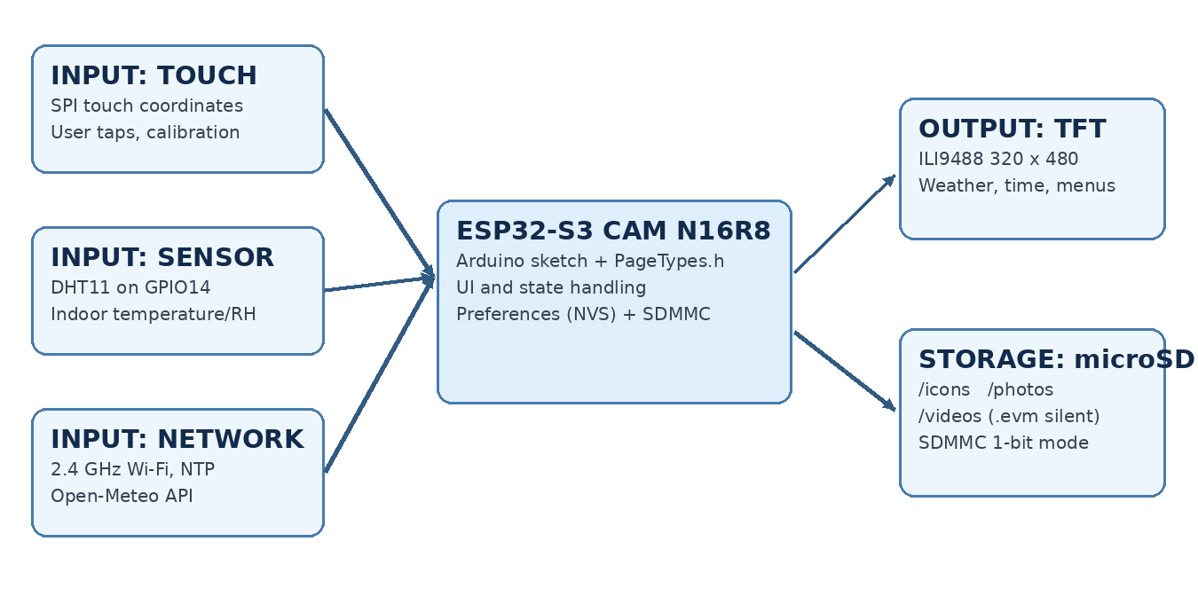
Figure 1. ERINX Smart Hub functional architecture (source-based schematic).

5.2 Arduino Firmware
The final application is stored as firmware/final/ERINX_Smart_Hub_V5_1_3_UI_Controls/ERINX_Smart_Hub_V5_1_3_UI_Controls.ino. The PageTypes.h header in the same sketch folder defines UI page identifiers and prevents Arduino prototype-generation errors related to the Page type. No source code was modified during repository reorganization.

5.3 Final ESP32-S3 Pin Reference
Peripheral | Connection | GPIO / note
Display | CS, DC, RST | 42, 41, 48
Shared SPI | TFT MOSI/T_DIN, TFT SCK/T_CLK | 21, 47
Touch | T_DO (MISO), T_CS | 1, 2
DHT11 | Digital DATA | 14
Built-in microSD | SDMMC CLK, CMD, D0 | 39, 38, 40 (1-bit mode)

The archived ESP32-S3 TFT_eSPI reference selects ILI9488_DRIVER, TFT 20 MHz SPI and 2.5 MHz touch SPI. Display VCC and backlight supply ratings must be checked against the actual TFT module; the code archive alone cannot establish its power tolerance.

5.4 Weather Data and Locations
The system calls https://api.open-meteo.com/v1/forecast with the selected latitude and longitude, requesting current temperature_2m, relative_humidity_2m, apparent_temperature, weather_code, is_day and wind_speed_10m. The timezone parameter is Asia/Manila. An ordinary refresh is scheduled about every 10 minutes, with retry after approximately one minute when data is invalid. Selecting a different city saves it to Preferences and requests fresh data.
Location | Latitude | Longitude
Malvar | 14.05425 | 121.15479
Tanauan | 14.06741 | 121.15311
Lipa | 13.96816 | 121.15909
Sto. Tomas | 14.11073 | 121.14236

Coordinates above reproduce the values stored in V5.1.3. The URL assembly formats latitude/longitude to four decimal places, so the transmitted point is rounded to that precision; the resulting weather information is a grid/area estimate rather than a surveyed reading at the landmark.

5.5 Sensor and Time Update Logic
The firmware samples DHT11 every 3,000 ms and checks for invalid (NaN) results before publishing local readings. Internet clock initialization depends on the saved/selected Wi-Fi connection. The interface continues to show local uptime when time synchronization has not completed.

5.6 Gallery, SD Icons and Silent Video
The sketch loads six 40 × 40 pixels RGB565 icon files (3,200 bytes each) from /icons. The gallery lists baseline JPEGs from /photos and supports auto-advance about every seven seconds. The video browser reads custom /videos/*.evm files with the ERXV signature and a 16-byte little-endian header, followed by length-prefixed JPEG frames. The video format has no audio track and is not a general-purpose MP4 player. The PC converter prepares the source videos before copy to the card.

5.7 Wi-Fi Setup and NVS Persistence
On-device Wi-Fi Setup scans nearby 2.4 GHz networks, accepts password characters from a touch keyboard and attempts to connect. The password field is visible while typing by default in V5.1.3; tapping the eye icon toggles masking. Only successful credentials are saved for reuse. These settings are on the microcontroller, not uploaded by the project. The design does not add an encryption layer around locally saved passwords; the SHOW/HIDE feature is useful for usability but requires attention during public demonstrations.

6. Procedure

6.1 Hardware Assembly
1. Ensure all modules and the USB power connection are OFF before wiring.
2. Connect the TFT display SPI, control and touchscreen lines to the ESP32-S3 GPIO assignments shown in Section 5.3.
3. Connect DHT11 DATA to GPIO14, its module VCC to a suitable 3.3 V rail, and GND to shared system ground.
4. Insert a supported FAT32 microSD card into the ESP32-S3 CAM board’s built-in slot; no separate external SD-card wiring is required.
5. Confirm TFT VCC/backlight ratings from the exact module and reuse the previously working display supply connection.
6. Connect the ESP32-S3 to a laptop with an appropriate USB data cable for flashing and Serial output.

6.2 Arduino IDE and Libraries
1. Select ESP32S3 Dev Module in the Espressif ESP32 board package; match 16 MB flash and OPI PSRAM in the working setup.
2. Install TFT_eSPI, TJpg_Decoder, ArduinoJson v7, DHT sensor library and Adafruit Unified Sensor.
3. Configure the active TFT_eSPI User_Setup.h using the known-good ILI9488 and touch settings. The archived ESP32-S3 reference header is in hardware/configs.
4. Open ERINX_Smart_Hub_V5_1_3_UI_Controls.ino from firmware/final/...; do not separate it from PageTypes.h.
5. Run Verify in Arduino IDE and then Upload. For runtime diagnostics, open Serial Monitor at 115200 baud.

6.3 Preparing microSD Media
1. Copy icons, photos and videos from sd_card/COPY_TO_SD_ROOT to the ROOT of the microSD card, retaining these directory names.
2. Use supplied 40 × 40 RGB565 icon files for the six home tiles.
3. Use portrait-compatible baseline JPEG photos in /photos. Large images may be downscaled by the decoder.
4. Convert ordinary PC videos using tools/video_converter/convert_videos.py and its dependencies into silent .evm files before copying them to /videos.
5. Keep benchmark clips separately inside firmware/diagnostics if testing FPS; the final application does not require the benchmark files.

6.4 Operation
1. Power the ESP32-S3 and complete touchscreen calibration on the initial run.
2. From Settings → Wi-Fi Setup, scan and connect to an available supported network; use SHOW/HIDE if needed.
3. Open Weather and choose Malvar, Tanauan, Lipa or Sto. Tomas; allow internet weather data to load.
4. Open Clock for Philippine time or uptime; open DHT11 for room temperature/humidity.
5. Open Gallery or Video for SD media, and use the available navigation/playback controls.
6. Restart and verify retained settings and behavior using the practical testing checklist in the project archive.

7. How It Works
1. The ESP32-S3 initializes the TFT display, loads or calibrates the touch controller, mounts built-in SDMMC storage and starts the DHT11 interface.
2. Local Preferences are read to restore city selection and saved Wi-Fi settings. Network connection/NTP synchronization is started when credentials are available.
3. The dashboard displays six functional tiles and observes touchscreen input through TFT_eSPI.
4. When Weather is selected, HTTP requests retrieve Open-Meteo current conditions for the chosen coordinates; the UI maps weather codes to simple screen graphics.
5. The DHT11 is sampled every three seconds, while current time and other UI content are refreshed according to independent timers.
6. SD icon reads and photo/video file browsers access /icons, /photos and /videos through SD_MMC; JPEG decoding produces TFT pixels.
7. The active page remains responsive to taps while scheduling state updates and drawing only changed or necessary visual elements.

8. Flow Chart
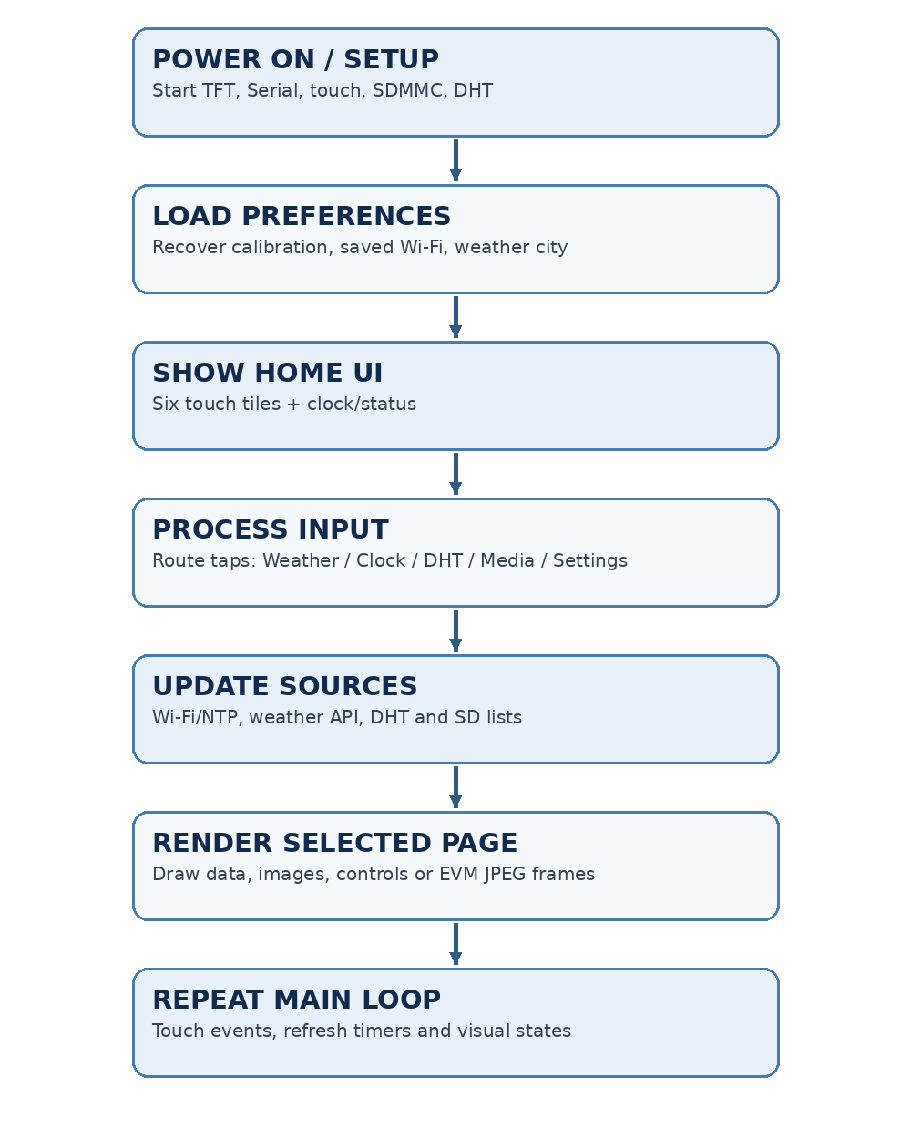
Figure 2. Main firmware interaction and update loop (conceptual).

9. Testing and Verification

9.1 Source Archive Review
The supplied TFT project.zip contained 172 file entries, including 22 distinct Arduino sketches. A checksum review identified 103 unique file-content hashes across the input archive, revealing numerous repeated icon, sample media and release-note files. The organized repository consolidates identical assets, preserves every distinct sketch byte-for-byte, and maintains required PageTypes.h copies next to corresponding sketches.

9.2 Functional Test Plan
Test | Expected behavior | Evidence / recorded result
Boot + display + touch | Portrait home opens; six tiles and BACK respond. | Hardware verification not provided
Indoor sensor | DHT11 displays a valid reading or an appropriate offline message. | Hardware verification not provided
Wi-Fi join / SHOW-HIDE | Touch password entry can be revealed/masked; connection can be saved. | Hardware verification not provided
Four weather cities | Selecting each city refreshes current conditions when online. | Hardware verification not provided
Clock | Time synchronization is shown when online, or uptime offline. | Hardware verification not provided
MicroSD and photos | SD card mounts; six icons load and baseline photos display. | Hardware verification not provided
EVM video | Converted silent video playback/navigation works. | Hardware verification not provided
Arduino Verify / Upload | Final .ino compiles with PageTypes.h and correct ESP32-S3 build setup. | Board-toolchain compile not performed here

9.3 Testing Limitations
The available files contain source code, README setup notes, graphics previews and example media, but no complete authenticated set of measured V5.1.3 hardware performance results. Therefore no actual FPS, error rate, current draw, sensor accuracy, boot time or success percentage is claimed in this report. The separate FPS benchmark sketch is available to measure display throughput on physical hardware when needed.

10. Results and Discussion
Source inspection confirms that the latest sketch integrates a six-tile home screen and independent Weather, Clock, DHT11, Gallery, Video and Settings page handlers. Earlier release branches document the project’s progression from basic ESP32D display/touch tests into a multi-feature ESP32-S3 dashboard. The consolidated repository now exposes the final sketch prominently and places converters, diagnostics, SD media and historical variants in distinct locations.
This architecture highlights constraints common in embedded applications. Network data and local sensor data have different availability and refresh schedules. The SD card requires suitable file formats and mount initialization. JPEG decoding, TFT drawing and video playback compete for processor time and PSRAM. A practical demonstration should therefore focus on correct interaction, recovery when the internet/SD is missing, and a calibrated touch/display response rather than assuming that every feature is guaranteed without testing.
The on-device Wi-Fi interface reduces the need to recompile credentials but introduces privacy considerations. The password visibility toggle improves error correction while its visible-by-default behavior requires caution when presenting. The firmware’s TLS setInsecure choice and non-encrypted app-level NVS storage are important prototype limitations, not recommended production security practices.

11. Conclusion
ERINX Smart Hub V5.1.3 is a complete source-level integration of touchscreen interaction, a local DHT11 sensor, online weather, time services, microSD media browsing and on-device Wi-Fi setup using an ESP32-S3 CAM N16R8 and a 3.5-inch SPI TFT. The organized submission preserves the full development trail while clearly identifying the final Arduino sketch and required SD-card assets.
The project offers a practical demonstration of peripheral communication, embedded interface design, data acquisition, network services, non-volatile storage and media processing. Its archived features can be explained and demonstrated on hardware; quantitative performance, sensor accuracy and physical reliability remain matters for measured testing rather than unverified claims.

12. Future Improvements
- Add certificate verification for HTTPS weather retrieval and consider safer local handling of saved Wi-Fi credentials.
- Improve UI password privacy defaults or show only the last typed character during entry.
- Implement camera/photobooth capability using the attached ESP32-S3 camera module as a separate optional feature.
- Add an alarm or notification sound through supported audio hardware and appropriate playback code.
- Profile frame-rate, memory use, Wi-Fi reconnection latency and DHT11 update stability using recorded benchmark data.
- Add measured power consumption and SD-card recovery tests for long-running operation.

13. Appendices

13.1 Source Code / Repository
Final Arduino sketch: firmware/final/ERINX_Smart_Hub_V5_1_3_UI_Controls/ERINX_Smart_Hub_V5_1_3_UI_Controls.ino. Required companion header: PageTypes.h in that same folder. Main guide: README.md. Complete source mapping: docs/SOURCE_FILE_MANIFEST.csv. The actual GitHub repository URL may be added after upload. Avoid committing locally edited passwords, binary build artifacts and secrets.

13.2 Example Media and Design Reference
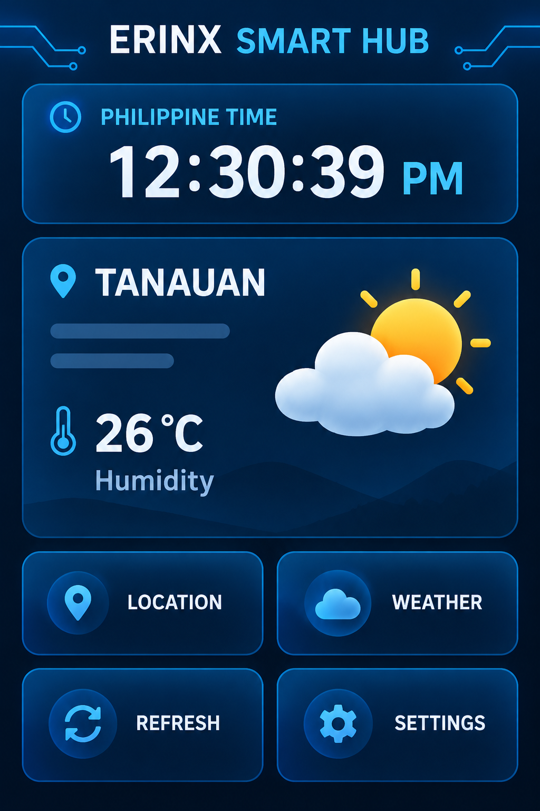
Figure 3. Archived ERINX dashboard mockup — conceptual design, not a photograph of the final V5.1.3 device.

13.3 Required Project Photographs
Before final submission, insert the actual hardware photographs and screenshots below. These placeholders do not imply that testing has already been completed.
INSERT ACTUAL PROJECT PHOTO OR SCREENSHOT HERE
Figure 4. Assembled ESP32-S3 CAM, TFT screen, DHT11 and wiring.
INSERT ACTUAL PROJECT PHOTO OR SCREENSHOT HERE
Figure 5. Home screen with six menu tiles on the physical TFT.
INSERT ACTUAL PROJECT PHOTO OR SCREENSHOT HERE
Figure 6. Weather screen showing one selected city and loaded weather data.
INSERT ACTUAL PROJECT PHOTO OR SCREENSHOT HERE
Figure 7. DHT11 reading, Wi-Fi password SHOW/HIDE and gallery/video demonstration.

13.4 Demonstration Note
A complete physical demonstration can follow the power-up, calibration, Wi-Fi, weather, sensor and microSD operation sequence in Section 6.4. Keep timestamped photographs or Serial logs as separate evidence of actual device tests.

